Equity Model Updates and Results

**Scenario:**

* Retire coal plants in VA and MD.
* RE sites in Mid-Atlantic states at 0.5o resolution for 3 years. The model should therefore have 374 Wind sites and 374 Solar sites available to it.
* Num Years for model is 3.

**Initial results:**

* 198 sites have reInvest indicator and reOnline indicator.
* BUT only 26 RE investments are valid (0+ MW)
* 8 sites are ineligible.

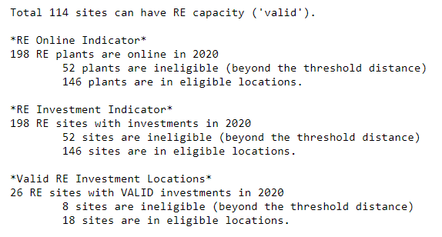

* RE generation is 2x HISTORICAL generation that needs replacement. For all years, the reGen = HISTGEN per constraint 3.

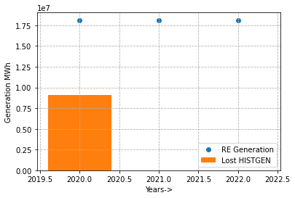

**Results:**

* Model wants to make 0 MW investments in ineligible sites.
* Grey circles are eligible sites. Blue circles show reGen. Red crosses denote ineligible sites.
* Note that there are 4 unique reSites that have considerable generation but are ineligible. These sites host total 8 RE investments.

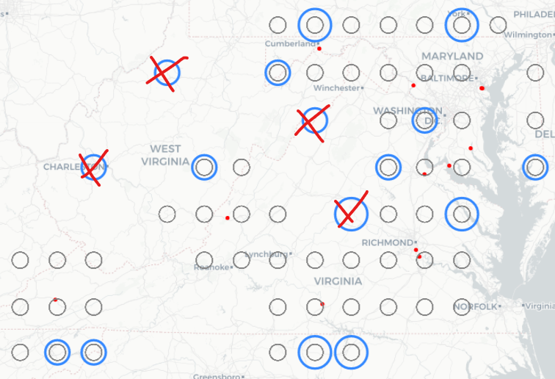

**Issues:**

* RE Overgeneration and not replacing HISTGEN per constraint 3
* RE generation in ineligible sites
* Investing and bringing online 0 MW RE sites.
* Constraint 11 violated, # of RE investments (198) > maximum RE sites allowed for all retired coal plants (120).

**Troubleshooting:**

* Printout of model was saved (can upload to Google Drive if needed)
* Warnings were noted in the Pyomo printout:

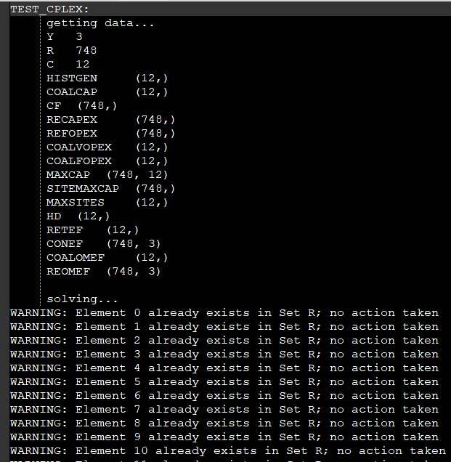

**RE Sites Index**

Based on the warnings above, RE Sites Index in the model was investigated. The code is using index values for reSites DF to set up members of set R. However, the index values for reSites DF (for n sites) are 0,1,2,…,n-1,0,1,2…,n-1 for both technology type W and S. Since the index repeats, Pyomo gives the above warning for the second set of reSites with duplicate indices.

Based on the Pyomo logs, the downstream impact of above Warning is that model thinks it only has 374 RE sites available. Set declarations in Pyomo are also then done for 374 sites only. Example: for 748 site options, CONEFre,year should have 3x748 = 2244 elements, however the set only has 1122 elements.

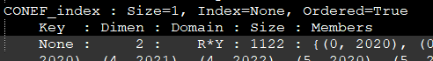

The figure below shows change made in yellow highlight. Direct impact of this change is the Pyomo warnings are gone. The model log confirmed that CONEF_index now contains 2244 elements, as expected.

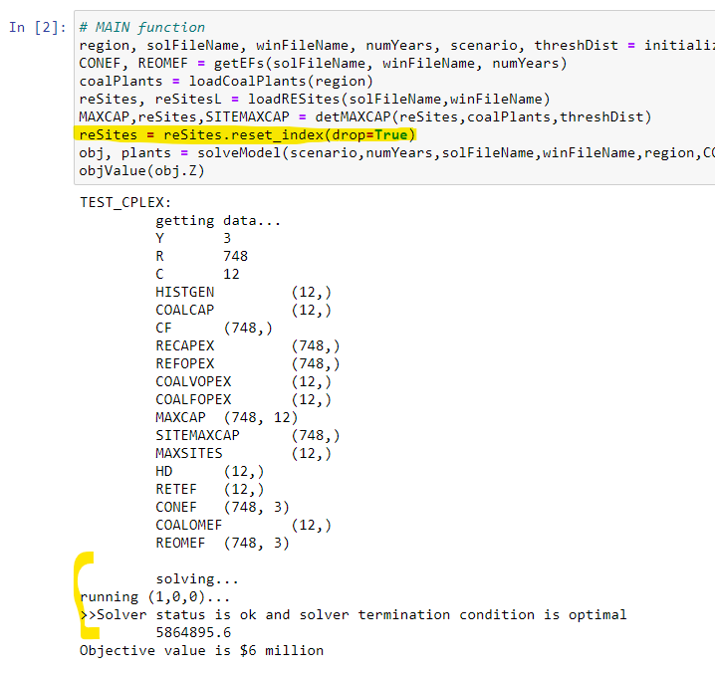

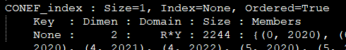

**Initial results:**

* 58 sites have reInvest indicator and reOnline indicator.
* BUT only 13 RE investments are valid (0+ MW)
* 0 sites are ineligible.

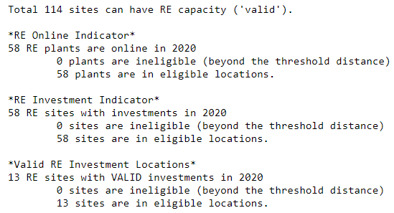

* RE generation = HISTORICAL generation for all years. Constraint 3 satisfied.

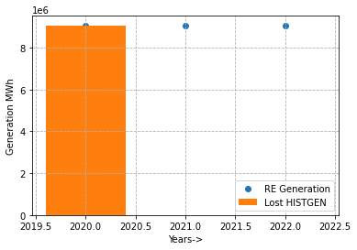

**Results:**

* Model still wants to make 0 MW investments, BUT all sites are eligible.
* Grey circles are eligible sites. Blue circles show reGen.

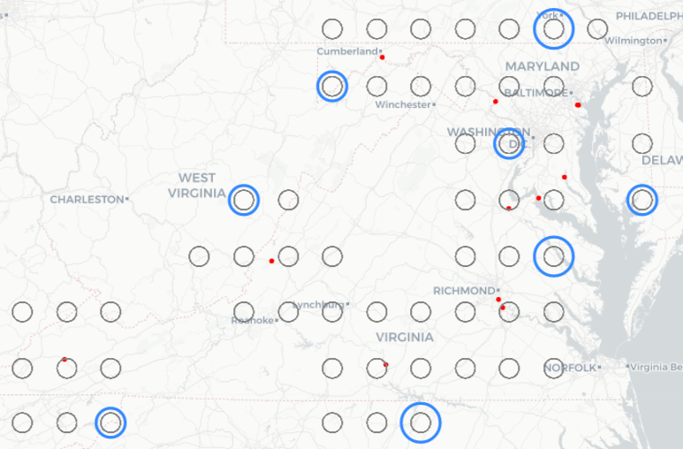

**Issues resolved:**

* RE overgeneration
* Investing in and bringing ineligible sites online
* Constraint 11 satisfied, 58 < 120.

**Remaining Issues:**

* RE sites with 0 MW capacity are brought online.
  + Consider altering constraint 10 or add a constraint to say if any RE site is online, then its reCapre,coal,year > 0.
  + OR constraint 10 can be changed to be an inequality where reInvestre,coal,year <= reOnlinere,coal,year – reOnlinere,coal,year-1.
    - The above scenario was executed with this update. The model doesn’t do 0 MW RE investments, and only 13 investments are made. However, the reOnline indicator is very high and the model may need a new constraint to limit reOnline indicator counts similar to constraint 11.

